Necessary Formulas:

- Entropy, E = – ∑ p_{i} log₂ p_{i |}; i = 1 to k, where k = number of classes.
- Average Entropy, E_{New} = ( ∑ − V_{ij} log₂ V_{ij} + ∑ S_{j} log₂ S_{j} )/N|;
i = 1 to k, where k = number of classes and
j = 1 to n, where n = number of unique values for an attribute and
- Information Gain, Ig = E_{Start} - E_{New}

Iteration 1 (For Selecting the Root Node)

We have 3 classes. So, The Value of Initial Entropy, E_{Start} will be:

E_{Start} = – p₁ log₂ p₁ – p₂ log₂ p₂ – p₃ log₂ p₃

There are 4 instances with classification 1, 5 instances with classification 2 and 15 instances with classification 3. So, p₁ = (4/24), p₂ = (5/24) and p₃ = (15/24).

E_{Start} = – (4/24) log₂ (4/24) – (5/24) log₂ (5/24) – (15/24) log₂ (15/24)
= 0.4308 + 0.4715 + 0.4238
= 1.3261 bits

Now, we need to calculate E_{New} for each of the attributes.

Frequency Table for Age  Age = 1 Age = 2 Age = 3  Class 1 2 1 1  Class 2 2 2 1  Class 3 4 5 6  Sum 8 8 8 | E_{New} (Age) = (− 2 log₂ 2 − 1 log₂ 1 − 1 log₂ 1 − 2 log₂ 2 − 2 log₂ 2 − 1 log₂ 1 − 4 log₂ 4 − 5 log₂ 5 − 6 log₂ 6 + 8 log₂ 8 + 8 log₂ 8 + 8 log₂ 8) / 24  = 1.2867
Frequency Table for SpecRx  SpecRx = 1 SpecRx = 2  Class 1 3 1  Class 2 2 3  Class 3 7 8  Sum 12 12 | E_{New} (SpecRx) = (− 3 log₂ 3 − 1 log₂ 1 − 2 log₂ 2 − 3 log₂ 3 − 7 log₂ 7 − 8 log₂ 8 + 12 log₂ 12 + 12 log₂ 12)/24  = 1.2866
Frequency Table for Astig  Astig = 1 Astig = 2  Class 1 0 4  Class 2 5 0  Class 3 7 8  Sum 12 12 | E_{New} (Astig) = (− 0 − 4 log₂ 4 − 5 log₂ 5 – 0 − 7 log₂ 7 − 8 log₂ 8 + 12 log₂ 12 + 12 log₂ 12)/24  = 0.9491
Frequency Table for Tears  Tears = 1 Tears = 2  Class 1 0 4  Class 2 0 5  Class 3 12 3  Sum 12 12 | E_{New} (Tears) = (− 0 − 4 log₂ 4 – 0 – 5 log₂ 5 − 12 log₂ 12 − 3 log₂ 3 + 12 log₂ 12 + 12 log₂ 12)/24  = 0.7773

Ig (Age) = E_{Start} – E_{New} (Age) = 1.3261 – 1.2867 = 0.0394
Ig (SpecRx) = E_{Start} – E_{New} (SpecRx) = 1.3261 – 1.2866 = 0.0395
Ig (Astig) = E_{Start} – E_{New} (Astig) = 1.3261 – 0.9491 = 0.377
Ig (Tears) = E_{Start} – E_{New} (Tears) = 1.3261 – 0.7773 = 0.5488

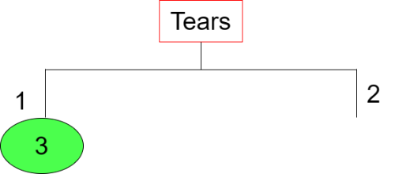

Iteration 2 (For Branch Tears = 2)

There are 4 instances with classification 1, 5 instances with classification 2 and 3 instances with classification 3. So, p₁ = (4/12), p₂ = (5/12) and p₃ = (3/12).

E_{Start} = – (4/12) log₂ (4/12) – (5/12) log₂ (5/12) – (3/12) log₂ (3/12)
= 0.5283 + 0.5263 + 0.5
= 1.5546 bits

Now, we need to calculate E_{New} for each of the attributes.

Frequency Table for Age  Age = 1 Age = 2 Age = 3  Class 1 2 1 1  Class 2 2 2 1  Class 3 0 1 2  Sum 4 4 4 | E_{New} (Age) = (– 2 log₂ 2 – 1 log₂ 1 – 1 log₂ 1 – 2 log₂ 2 – 2 log₂ 2 – 1 log₂ 1 – 0 – 1 log₂ 1 – 2 log₂ 2 + 4 log₂ 4 + 4 log₂ 4 + 4 log₂ 4)/12  = 1.3333
Frequency Table for SpecRx  SpecRx = 1 SpecRx = 2  Class 1 3 1  Class 2 2 3  Class 3 1 2  Sum 6 6 | E_{New} (SpecRx) = (– 3 log₂ 3 – 1 log₂ 1 – 2 log₂ 2 – 3 log₂ 3 – 1 log₂ 1 – 2 log₂ 2 + 6 log₂ 6 + 6 log₂ 6) / 12  = 1.4592
Frequency Table for Astig  Astig = 1 Astig = 2  Class 1 0 4  Class 2 5 0  Class 3 1 2  Sum 6 6 | E_{New} (Astig) = (0 – 4 log₂ 4 – 5 log₂ 5 – 0 – 1 log₂ 1 – 2 log₂ 2 + 6 log₂ 6 + 6 log₂ 6)/12  = 0.7842

Ig (Age) = E_{Start} – E_{New} (Age) = 1.5546 – 1.3333 = 0.2213
Ig (SpecRx) = E_{Start} – E_{New} (SpecRx) = 1.5546 – 1.4592 = 0.0954
Ig (Astig) = E_{Start} – E_{New} (Astig) = 1.5546 – 0.7842 = 0.7704

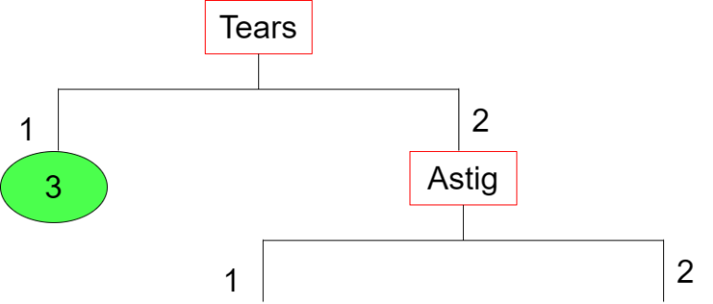

Iteration 3 (For Branch Astig = 1)

There are 5 instances with classification 2 and 1 instance with classification 3. So, p₁ = (5/6) and p₂ = (1/6).

E_{Start} = – (5/6) log₂ (5/6) – (1/6) log₂ (1/6)
= 0.2192 + 0.4308
= 0.65 bits

Now, we need to calculate E_{New} for each of the attributes.

Frequency Table for Age  Age = 1 Age = 2 Age = 3  Class 1 0 0 0  Class 2 2 2 1  Class 3 0 0 1  Sum 2 2 2 | E_{New} (Age) = (0 – 0 – 0 – 2 log₂ 2 – 2 log₂ 2 – 1 log₂ 1 – 0 – 0 – 1 log₂ 1 + 2 log₂ 2 + 2 log₂ 2 + 2 log₂ 2)/6  = 0.3333
Frequency Table for SpecRx  SpecRx = 1 SpecRx = 2  Class 1 0 0  Class 2 2 3  Class 3 1 0  Sum 3 3 | E_{New} (SpecRx) = (0 – 0 – 2 log₂ 2 – 3 log₂ 3 – 1 log₂ 1 – 0 + 3 log₂ 3 + 3 log₂ 3)/6  = 0.4592

Ig (Age) = E_{Start} – E_{New} (Age) = 0.6500 – 0.3333 = 0.3167
Ig (SpecRx) = E_{Start} – E_{New} (SpecRx) = 0.6500 – 0.4592 = 0.1908

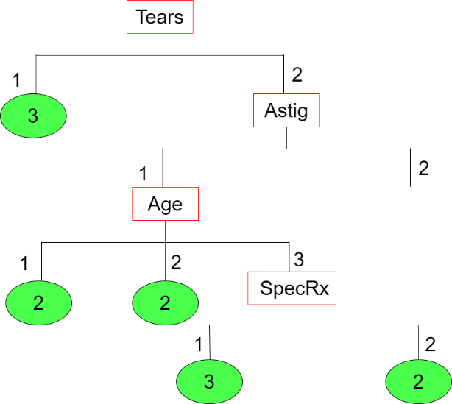

Iteration 4 (For Branch Astig = 2)

There are 4 instances with classification 1 and 2 instance with classification 3. So, p₁ = (4/6) and p₂ = (2/6).

E_{Start} = – (4/6) log₂ (4/6) – (2/6) log₂ (2/6)
= 0.3900 + 0.5283
= 0.9183 bits

Now, we need to calculate E_{New} for each of the attributes.

Frequency Table for Age  Age = 1 Age = 2 Age = 3  Class 1 2 1 1  Class 2 0 0 0  Class 3 0 1 1  Sum 2 2 2 | E_{New} (Age) = (– 2 log₂ 2 – 1 log₂ 1 – 1 log₂ 1 – 0 – 0 –0 – 0 – 1 log₂ 1 – 1 log₂ 1 + 2 log₂ 2 + 2 log₂ 2 + 2 log₂ 2)/6  = 0.6667
Frequency Table for SpecRx  SpecRx = 1 SpecRx = 2  Class 1 3 1  Class 2 0 0  Class 3 0 2  Sum 3 3 | E_{New} (SpecRx) = (– 3 log₂ 3 – 1 log₂ 1 – 0 – 0 – 0 – 2 log₂ 2 + 3 log₂ 3 + 3 log₂ 3)/6  = 0.4592

Ig (Age) = E_{Start} – E_{New} (Age) = 0.9183 – 0.6667 = 0.2516
Ig (SpecRx) = E_{Start} – E_{New} (SpecRx) = 0.9183 – 0.4592 = 0.4591

